
Allergen List: Today’s Menu
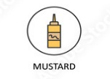
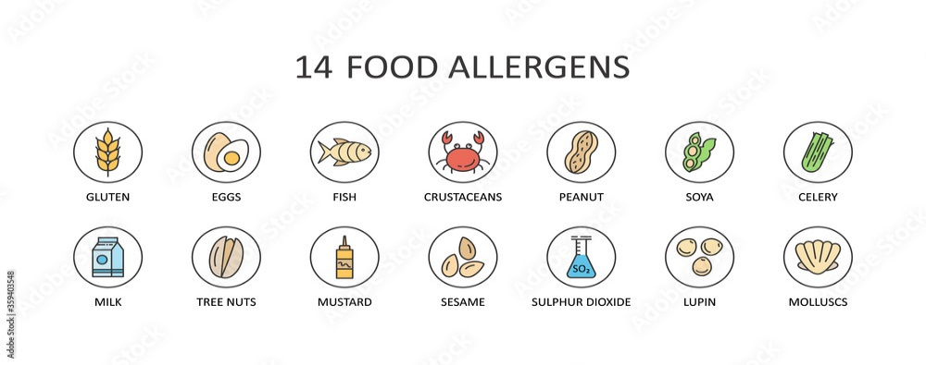
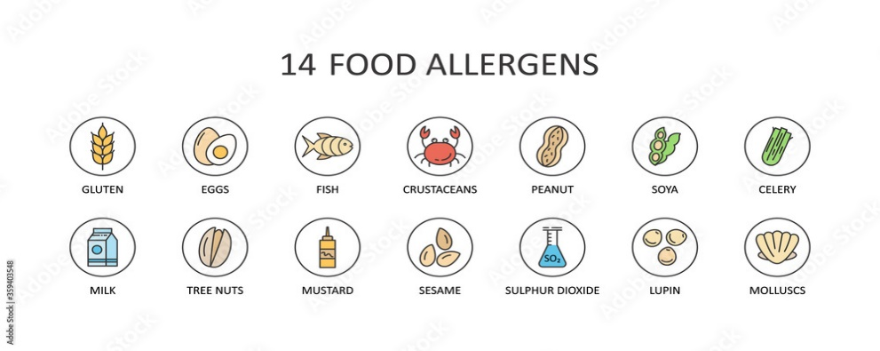
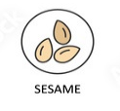
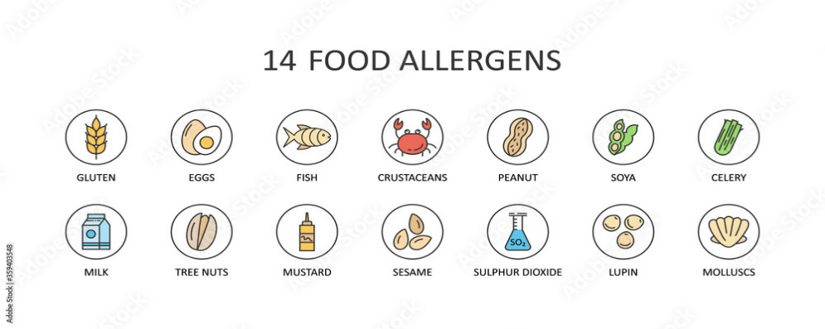
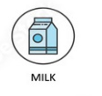
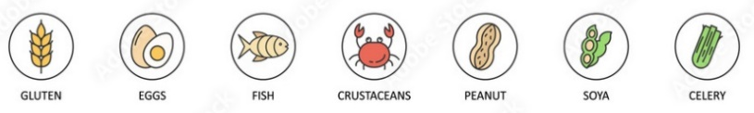
DISH
Roasted Pepper & Tomato Soup (V)(VE)(GF)(DF) |  |  |  |  |  |  | X |  |  |  |  | X
Lentils, Squash & Rocket Salad (V)(VE)(DF) | M |  |  |  |  |  | M |  |  |  |  | X
Courgette, Cucumber, Peppers, Baby Gem (V)(VE)(GF)(DF)
Chicken & Mushroom Fricassee (GF) |  |  |  |  |  |  | M | X |  |  |  | X
Sweet Potato and Black Bean Chili (V)(VE)(DF) | M |  |  |  |  |  | M |  |  |  |  | X
Penne Pasta, Spinach, Nut free Pesto, Tomatoes (V)(VE)(DF) | X
Seasonal Vegetables (V)(VE)(GF)(DF)
Steamed Rice (V)(VE)(GF)(DF)
Bread Rolls (V) | X | M |  |  |  | X |  | M
Raspberry Torte  (Contains Gelatine) | X | X |  |  | M | M |  | X | M |  | M | X
Mango & Passionfruit Torte  (Contains Gelatine) | X | X |  |  | M | M |  | X | M |  | M | M
Irish Cream  (Contains Gelatine & Alcohol) | X | X |  |  | M | X |  | X | M |  | M | M
Greek Yoghurt (V)  with Honey, Dried Fruits & Seeds | M |  |  |  | M |  |  | X | M |  |  | X
Whole Fruits (V)(VE)(GF)(DF)

