
Allergen List: Today’s Menu
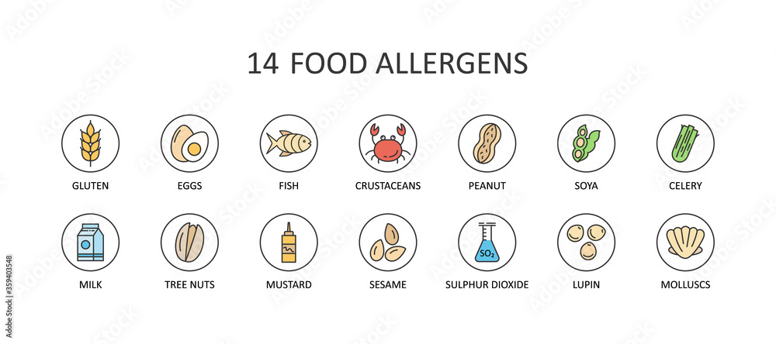
DISH
Cauliflower Soup (V)(VE)(GF)(DF) |  |  |  |  |  |  | X |  |  |  |  | X
Selection of Breads (V)(VE) | X | M |  |  |  | X |  | M
Roasted Sweet Potato, Pepper, Courgette & Toasted Pumpkin Seed Salad (V)(VE)(GF)(DF) |  |  |  |  |  |  | M |  |  |  |  | X
Red Cabbage & Pickled Onion Slaw (V)(VE)(GF) |  |  |  |  |  |  | M |  |  | M |  | X
Roasted Pollock with Egg Noodles and Soy sauce (DF) | X | X | X |  |  | X | X |  |  |  |  | X
Malabar Dhaal (V)(VE)(DF) | M |  |  |  |  |  | M |  |  | X | M | X
Moroccan Lamb Tagine (HALAL)(GF)(DF) |  |  |  |  |  |  | M |  |  |  |  | X
Scented Rice (V)(VE)(GF)(DF) |  |  |  |  |  |  | M |  |  |  |  | X
Roasted Root Vegetables (V)(VE)(GF)(DF) |  |  |  |  |  |  | X |  |  | M |  | X
Chocolate Torte  (Contains Gelatine) | X | X |  |  | M | X |  | X | M |  | M | M
Red Velvet Cake (V) | X | X |  |  | M | M |  | X | M |  | M | M
Whole Fruit (V)(VE)(GF)(DF)
Greek Yoghurt, Dried Fruits, Seeds & Honey (V) | M |  |  |  | M |  |  | X | M |  |  | X

